|  |
| --- |
| EPAM Systems, RD Dep. |
| Core PL SQL |

|  |  |  |  |  |  |
| --- | --- | --- | --- | --- | --- |
| REVISION HISTORY | | | | | |
| Ver. | Description of Change | Author | Date | Approved | |
| Name | Effective Date |
| 1.0 | Initial status | Arina Marchenko | 4-DEC-2017 |  |  |

Contents

1. Tables 3

2. Using cursors 6

3. Using merge 7

# Tables

On BL_CL layer there are two types of tables: wrk and cls.

WRK tables were needed for loading external tables because external tables need a lot of space and work worse. Because of that we made a WRK tables which had the same structure as external tables, but their performance higher.

CLS tables were made for 3nf scheme, because they have the same structure as tables from 3nf, and they were made for cleansing some unsuitable information and divided some information for using in 3nf.

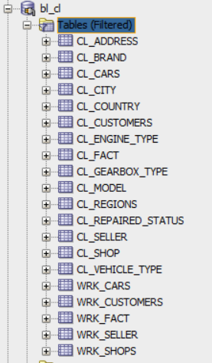

For loading wrk tables I used script below

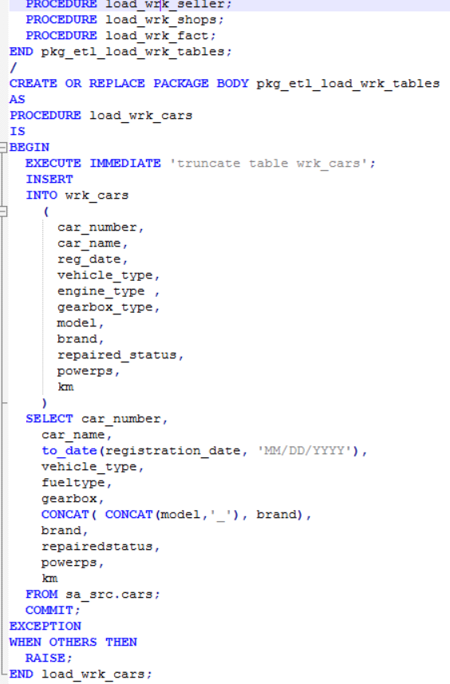

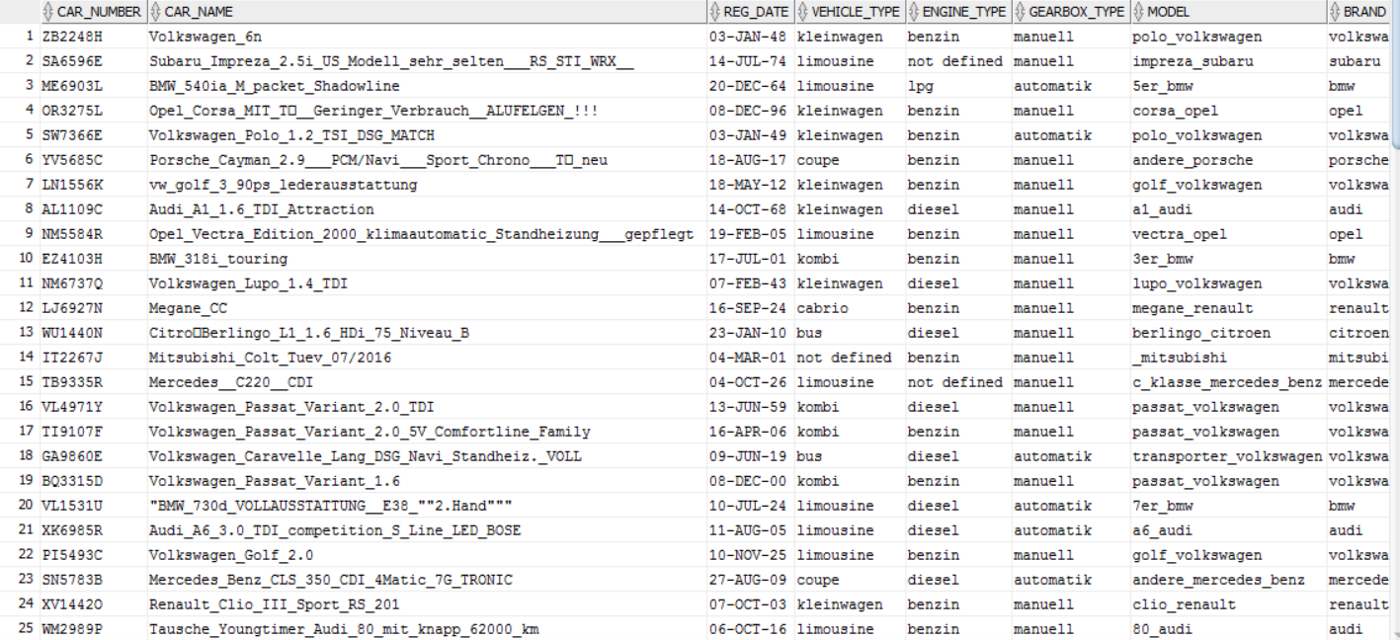

Also in this tables I used only the columns, which I need. So this scrips become a little bit more complicated. Moreover, I made such stuff, like -99, -98 and not defined for null values. So on this layer I have already replace nulls.

On CLS Layer I divide WRK tables into tables that I will have on 3nf layer. Also I got rid of repetitions and generate some date columns where needed.

For loading data from wrk to cls I used only implicit cursor.

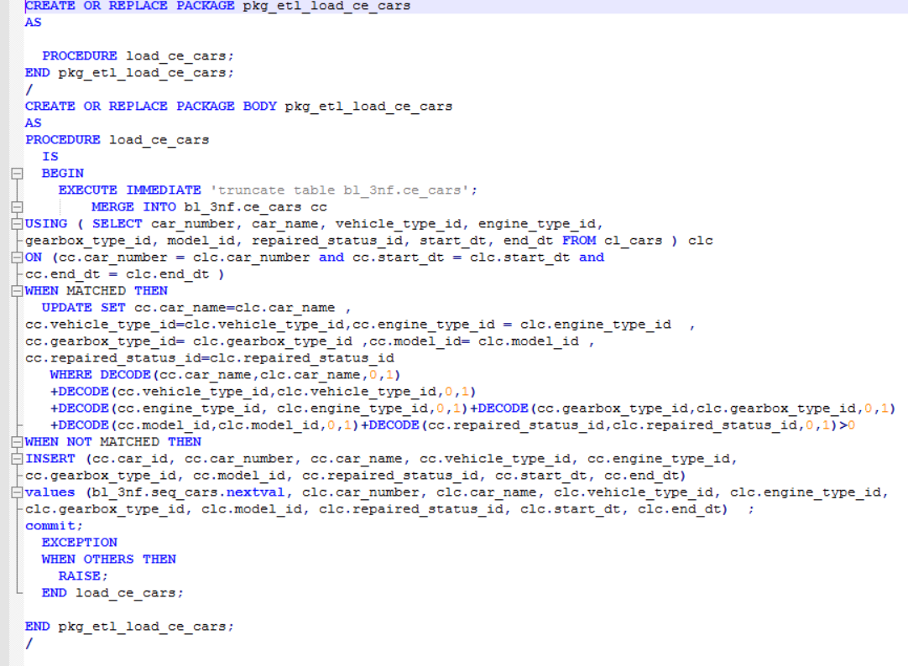

The script above was used for loading data from CLS to CE layer. Here I used merge for defining whether we already has this information or its updating. Here I also have date of last update.

Moreover on this layer I generated surr key which is primary key in CE for linking tables.

For loading data from cls to ce I used implicit and explicit cursors.

Packages, which were used for inserting data into ce are below:

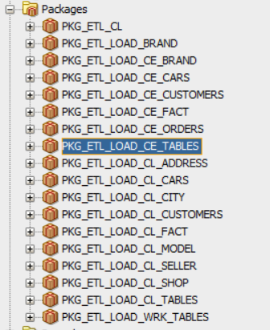

# Using cursors

Here is the script for explicit cursor:

CREATE OR REPLACE PACKAGE pkg_etl_load_ce_brand

AS

PROCEDURE load_ce_brand;

END pkg_etl_load_ce_brand;

/

CREATE OR REPLACE PACKAGE BODY pkg_etl_load_ce_brand

AS

PROCEDURE load_ce_brand

IS

CURSOR c_data

IS

SELECT DISTINCT cebr.rowid AS rid,

clbr.brand_name,

trunc(sysdate) update_dt

FROM cl_brand clbr

LEFT OUTER JOIN bl_3nf.ce_brand cebr

ON clbr.brand_name <> cebr.brand_name;

type t__data

IS

TABLE OF c_data%rowtype INDEX BY binary_integer;

t_data t__data;

BEGIN

EXECUTE IMMEDIATE 'truncate table bl_3nf.ce_brand';

OPEN c_data;

LOOP

FETCH c_data bulk collect INTO t_data ;

EXIT

WHEN t_data.count = 0;

FOR idx IN t_data.first .. t_data.last

LOOP

IF t_data(idx).rid IS NULL THEN

INSERT

INTO bl_3nf.ce_brand

(

brand_id,

brand_name,

update_dt

)

VALUES

(

bl_3nf.seq_brand.nextval,

t_data(idx).brand_name,

sysdate

);

ELSE

UPDATE bl_3nf.ce_brand

SET update_dt = sysdate

WHERE rowid = t_data(idx).rid ;

END IF;

END LOOP;

END LOOP;

CLOSE c_data;

COMMIT;

EXCEPTION

WHEN OTHERS THEN

RAISE;

END load_ce_brand;

END pkg_etl_load_ce_brand;

/

Implicit cursor are used while INSERT, UPDATE or SELECT INTO. You don’t need either declare them or open

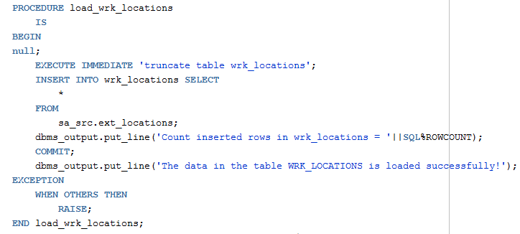

# Using merge

Here is the script for loading cars table from cls to ce.

PROCEDURE load_ce_cars

IS

BEGIN

EXECUTE IMMEDIATE 'truncate table bl_3nf.ce_cars';

MERGE INTO bl_3nf.ce_cars cc

USING ( SELECT car_number, car_name, vehicle_type_id, engine_type_id,

gearbox_type_id, model_id, repaired_status_id, start_dt, end_dt FROM cl_cars ) clc

ON (cc.car_number = clc.car_number and cc.start_dt = clc.start_dt and

cc.end_dt = clc.end_dt )

WHEN MATCHED THEN

UPDATE SET cc.car_name=clc.car_name ,

cc.vehicle_type_id=clc.vehicle_type_id,cc.engine_type_id = clc.engine_type_id ,

cc.gearbox_type_id= clc.gearbox_type_id ,cc.model_id= clc.model_id ,

cc.repaired_status_id=clc.repaired_status_id

WHERE DECODE(cc.car_name,clc.car_name,0,1)

+DECODE(cc.vehicle_type_id,clc.vehicle_type_id,0,1)

+DECODE(cc.engine_type_id, clc.engine_type_id,0,1)+DECODE(cc.gearbox_type_id,clc.gearbox_type_id,0,1)

+DECODE(cc.model_id,clc.model_id,0,1)+DECODE(cc.repaired_status_id,clc.repaired_status_id,0,1)>0

WHEN NOT MATCHED THEN

INSERT (cc.car_id, cc.car_number, cc.car_name, cc.vehicle_type_id, cc.engine_type_id,

cc.gearbox_type_id, cc.model_id, cc.repaired_status_id, cc.start_dt, cc.end_dt)

values (bl_3nf.seq_cars.nextval, clc.car_number, clc.car_name, clc.vehicle_type_id, clc.engine_type_id,

clc.gearbox_type_id, clc.model_id, clc.repaired_status_id, clc.start_dt, clc.end_dt) ;

commit;

EXCEPTION

WHEN OTHERS THEN

RAISE;

END load_ce_cars;